**CSS Flexbox**

**Lab report #01**



Fall 2023

CSE-423L Web Engineering

Submitted by: **Ashfaq Ahmad**

Registration No: **19PWCSE1795**

Class Section: **B**

“On my honor, as student of University of Engineering and Technology, I have neither given nor received unauthorized assistance on this academic work.”

Student Signature: ______________

Submitted to:

**Eng. Usman**

**March** 26, 2023

**Department of Computer Systems Engineering**

**University of Engineering and Technology, Peshawar**

**Task 01:**

For this task, you'll be working with `header.html` and `header.css`. In your HTML file figure out what your container element for your flexbox should be. Then, manipulate the **display** and **align-items** properties to recreate the figure given below:

**HTML Code:**

<!DOCTYPE html>

<!DOCTYPE html>

<html lang="en">

<head>

    <meta charset="UTF-8">

    <meta http-equiv="X-UA-Compatible" content="IE=edge">

    <meta name="viewport" content="width=device-width, initial-scale=1.0">

    <title>Header</title>

    <link rel="stylesheet" href="header.css">

</head>

<body>

    <div class="container">

        <li><span class="dot"></span></li>

        <li>Categories</li>

        <li>Deals</li>

        <li>Trending</li>

    </div>

    <hr>

    <h1>Ashfaq Ahmad</h1>

</body>

</html>

**CSS Code:**

*{

    margin: 0px;

    padding:0px;

}

.container{

    display: flex;

    background-color: rgb(195, 188, 188);

    height: 80px;

}

li{

    padding: 28px 15px;

    /* this padding is inside container class */

    list-style: none;

}

.dot{

    background-color: green;

    padding: 18px 25px;

    /* this padding is inside the dot class */

    border-radius: 100%;

}

**Result:**

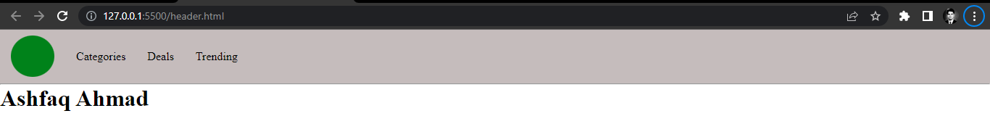

**Task 02:**

In this task you'll be working on `Nav_Side.html` and `Nav_Side.css`. Use the **display**, **flex direction** and **justify-content** properties to match the figure given below:

**HTML Code:**

<!DOCTYPE html>

<html lang="en">

<head>

    <meta charset="UTF-8">

    <meta http-equiv="X-UA-Compatible" content="IE=edge">

    <meta name="viewport" content="width=device-width, initial-scale=1.0">

    <title>Nav side bar</title>

    <link rel="stylesheet" href="Nav_side.css">

</head>

<body>

    <div class="container">

        <h3>Home</h3>

        <h3>Music </h3>

        <h3>Blog</h3>

        <h3>Shows</h3>

        <h3>Podcast</h3>

    </div>

    <h1>Ashfaq Ahmad</h1>

</body>

</html>

**CSS Code:**

*{

    margin: 0px;

    padding: 0px;

}

.container{

    display:flex;

    background-color: rgb(195, 188, 188);

    flex-direction: column;

    height: 600px;

    width: 200px;

    justify-content: space-between;

    padding: 0px 10px;

}

Result:

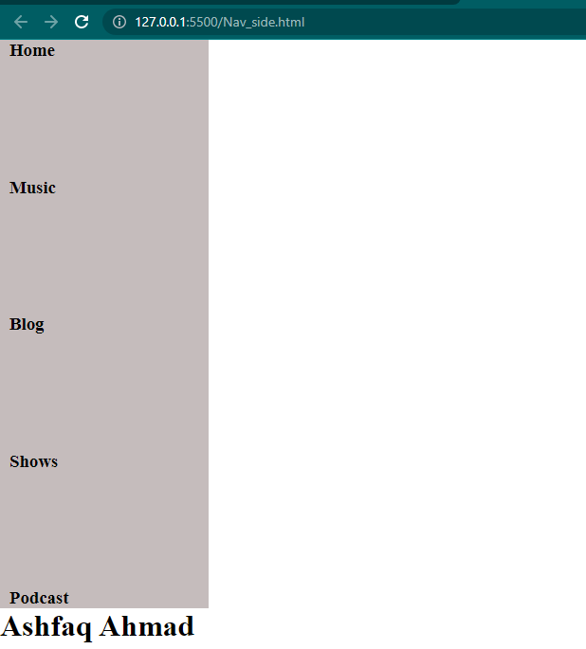

**Task 03:**

Now you'll be working in `footer.html` and `footer.css` to create a footer component for your page. Create the footer as shown below:

**HTML Code:**

<!DOCTYPE html>

<html lang="en">

<head>

    <meta charset="UTF-8">

    <meta http-equiv="X-UA-Compatible" content="IE=edge">

    <meta name="viewport" content="width=device-width, initial-scale=1.0">

    <title>Footer</title>

    <link rel="stylesheet" href="footer.css">

</head>

<body>

    <h1 style="text-align: center;">Ashfaq Ahmad</h1>

    <div class="container">

        <div class="container1">

            <h3>GIFT CARDS</h3>

            <h3>STUDENT DISCOUNT</h3>

            <h3>GIFT CARDS</h3>

            <h3>FIND A STORE</h3>

            <h3>SIGN FOR EMAIL</h3>

        </div>

        <div class="container2">

            <li><b>GET HELP</b></li>

            <li>Order Statu</li>

            <li>Shipping and Deliver</li>

            <li>Return</li>

            <li>Payment Option</li>

        </div>

        <div class="container3">

            <b>ABOUT US</b>

            <p> We are all committed to making  quality products available for all.</p>

            </div>

        </div>

    </div>

</body>

</html>

**CSS Code:**

*{

    padding: 0px;

    margin: 0px;

}

/* outer container setting */

 .container{

    height: 200px;

    width: 100%;

    display: flex;

    justify-content: space-between;

    background-color: gray;

    position: absolute;

    bottom: 0;

}

/* inner containers settings. combine method */

.container1,.container2,.container3{

    padding: 20px 90px 50px 90px;

    width: 140px;

    list-style: none;

}

**Result:**

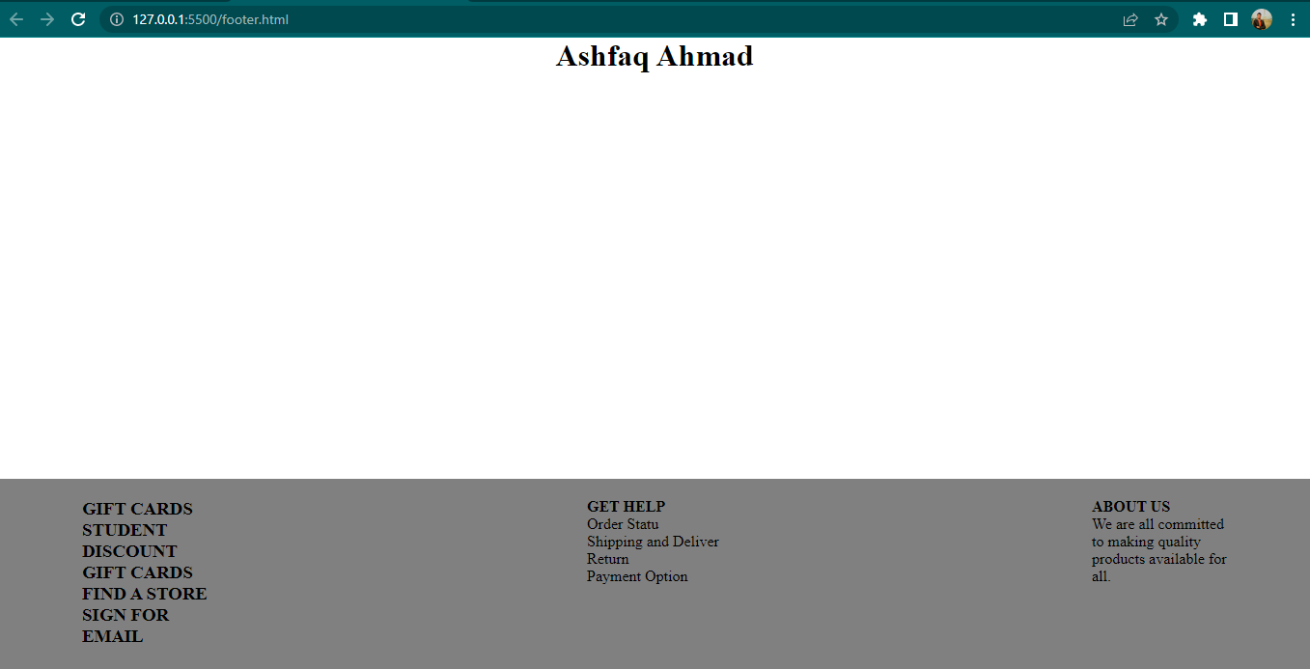

**Task 04:**

Now you'll be working in `center.html` and `center.css` to create a centered content

for your page. Create the centered content as shown below.

**HTML Code:**

<!DOCTYPE html>

<html lang="en">

<head>

    <meta charset="UTF-8">

    <meta http-equiv="X-UA-Compatible" content="IE=edge">

    <meta name="viewport" content="width=device-width, initial-scale=1.0">

    <title>Center</title>

    <link rel="stylesheet" href="center.css">

</head>

<body>

    <!-- To moving text horizontally we use text-align property while vertically we use margin-top or bottem. -->

    <h1 style="text-align: center; margin-top: 20px;">Ashfaq Ahmad</h1>

    <div class="container">

        <div class="item">

            <p>&#128578</p>

            <h1>Welcome to the app!</h1>

            <div>Thanks for syning up. Lets take a look around</div>

            <button>Begin tour</button>

        </div>

    </div>

</body>

</html>

**CSS Code:**

*{

    padding: 0px;

    margin: 0px;

}

/* by default each container size is equal the size of contents inside that container. we can play with its size by using dsiplay: flex; property and height, width properties of container.  */

.container{

    height: 500px;

    display: flex;

    flex-direction: column;

    justify-content:center;

    align-items: center;

    /* align-items and align-content works same but align-content don't work without flex-wrap property. */

    /* if flex-direction is vertical then justify-conetent work along y-axis and align-items and align-content works along x-axis. */

}

   .item{

    height: 200px;

    width: 300px;

    display: flex;

    flex-direction: column;

    align-items: center;

    justify-content:space-between;

    color: darkgray;

}

button{

    padding: 8px 15px;

    border-radius: 5px;

    border-color: dodgerblue;

    background-color: dodgerblue;

    color: white;

}

p{

    font-size: 40px;

}

**Result:**

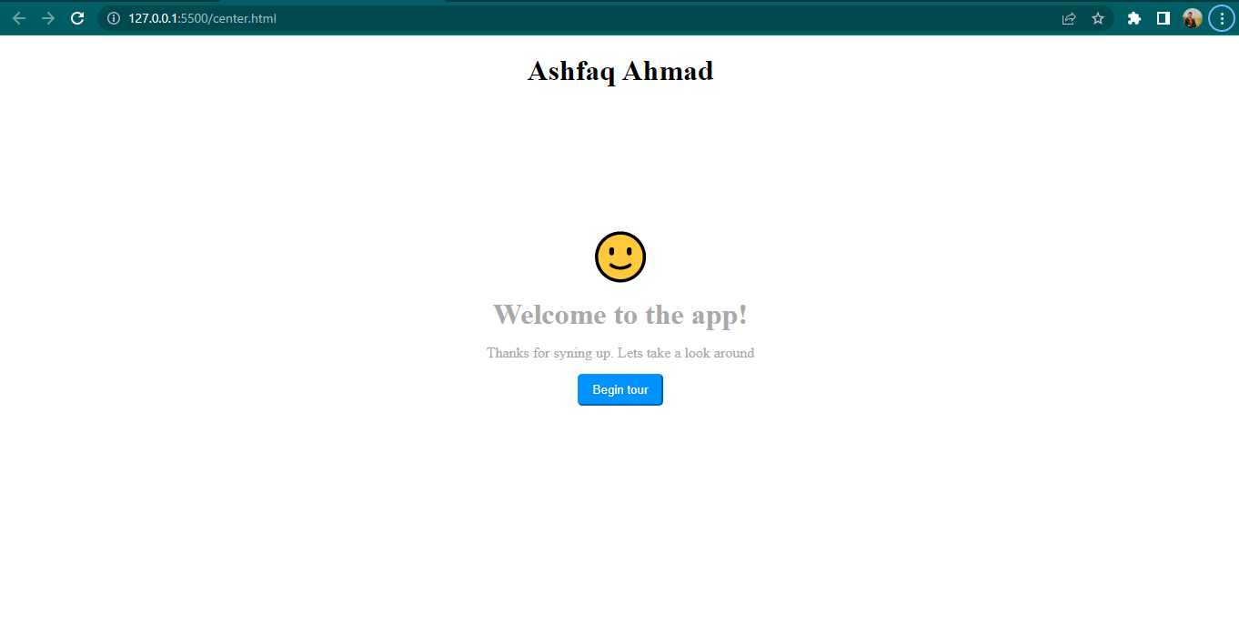

**Task 05:**

Go back into your `footer.css` file and modify it to achieve the results below. You'll want to treat each item div as its own 'container' element and use the same properties you've seen throughout this lab on each one.

**HTML Code:**

<!DOCTYPE html>

<html lang="en">

<head>

    <meta charset="UTF-8">

    <meta http-equiv="X-UA-Compatible" content="IE=edge">

    <meta name="viewport" content="width=device-width, initial-scale=1.0">

    <title>Extension</title>

    <link rel="stylesheet" href="extension.css">

</head>

<body>

    <h1>Ashfaq Ahmad</h1>

    <div class="container">

        <div class="container1">

            <h3>GIFT CARDS</h3>

            <h3>STUDENT DISCOUNT</h3>

            <h3>GIFT CARDS</h3>

            <h3>FIND A STORE</h3>

            <h3>SIGN FOR EMAIL</h3>

        </div>

        <div class="container2">

            <li><b>GET HELP</b></li>

            <li>Order Statu</li>

            <li>Shipping and Deliver</li>

            <li>Return</li>

            <li>Payment Option</li>

        </div>

        <div class="container3">

            <b>ABOUT US</b>

            <p> We are all committed to making  quality products available for all.</p>

            </div>

        </div>

    </div>

</body>

</html>

**CSS Code:**

*{

    margin: 0px;

    padding: 0px;

}

.container{

    height: 180px;

    width: 100%;

    background-color: rgb(195, 188, 188);

    position:absolute;

    bottom: 0;

    display: flex;

    justify-content: space-around;

    padding: 20px 0px;

}

.container1,

.container3{

    width: 210px;

    display: flex;

    flex-direction: column;

    justify-content: space-between;

}

.container2{

    list-style: none;

}

**Result:**

